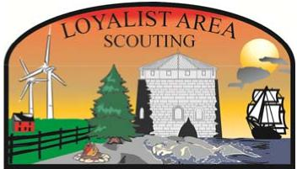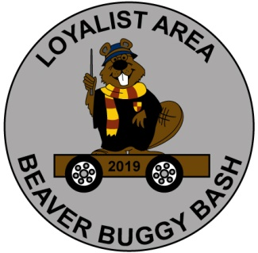

LOYALIST AREA BEAVER BUGGY BASH 2019
MARCH 23, 2019 8:45AM – 1:30PM
LANCASTER PUBLIC SCHOOL
1020 LANCASTER DRIVE
THEME: HARRY POTTER
REGISTRATION DEADLINE March 8, 2019
COST: BEAVERS AND SCOUTERS $7.00 (includes lunch and badge)
PARENTS $4.00 (lunch only)
LUNCH IS PIZZA (CHEESE OR PEPPERONI) CHIPS AND A JUICE BOX.
ACTIVITIES INCLUDE:
BUGGY RACES
HARRY POTTER ACTIVITIES
CRAFT
STORY TIME
CAMPFIRE SING ALONG AFTER LUNCH

BEAVER BUGGY BASH REGISTRATION FORM

NAME OF COLONY:______________________________
NUMBER OF BEAVERS:__________ *$7.00 = $________
NUMBER OF SCOUTERS:_________ *$7.00 = $________
NUMBER OF PARENTS:__________ *$4.00 = $________
TOTAL ATTENDING:_____________ $________

NUMBER OF CHEESE PIZZA:_____________________
NUMBER OF PEPPERONI:_______________________
TOTAL PIZZA (should equal # attending):__________
Please note: Parents do not need to stay as space is limited.
Return Registration Forms to.
Bill Racz 1362 Sierra Ave, Kingston, K7P 0B5 raczw@queensu.ca

ITENARY FOR THE DAY
REGISTRATION 8:45AM – 9:15AM
OPENING 9:15AM – 9:30AM
ACTIVITY 1 9:30AM – 9:55AM
SNACK 9:55AM – 10:10AM
ACTIVITY 2 10:10AM – 10:35AM
ACTIVITY 3 10:35AM – 11:05AM
ACTIVITY 4 11:05AM – 11:35AM
ACTIVITY 5 11:35AM – 12:05 PM
LUNCH 12:05PM – 12:45PM
CAMPFIRE (CLOSING) 12:45PM – 1:15PM

BEAVERS SHOULD BRING:
WATER BOTTLE, HAT, UNIFORM (PLEASE MAKE SURE THESE ARE LABELED)
INDOOR SHOES (THIS IS FOR SCOUTERS AND PARENTS AS WELL)

BEAVER BUGGY BASH REGISTRATION FORM (colony use)

NAME OF BEAVER ATTENDING:____________________________*$7.00
CHOICE OF PIZZA: CHEESE OR PEPPERONI (PLEASE CIRCLE)
NAME OF SCOUTER ATTENDING:____________________________*$7.00
CHOICE OF PIZZA: CHEESE OR PEPPERONI (PLEASE CIRCLE)
NAME OF PARENT ATTENDING:____________________________*$4.00
CHOICE OF PIZZA: CHEESE OR PEPPERONI (PLEASE CIRCLE)
TOTAL :$ ___________________

BEAVERS SHOULD BRING:
WATER BOTTLE, HAT, UNIFORM (PLEASE MAKE SURE THESE ARE LABELED)
INDOOR SHOES (THIS IS FOR SCOUTERS AND PARENTS AS WELL)

